**Samsung 870 EVO 500GB SSD SATA 2.5" - MZ-77E500**

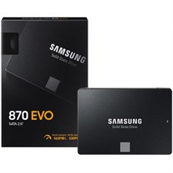

**Features:**

* **Storage Capacity**: 500GB  
  Ideal for laptops, desktops, and other systems needing high-speed and reliable storage.
* **Form Factor**: 2.5"  
  Compact design, compatible with a wide range of devices.
* **Interface**: SATA III (6Gb/s)  
  Backward compatible with SATA II and SATA I, ensuring broad compatibility.
* **Sequential Read Speed**: Up to 560 MB/s  
  Enhanced performance for faster boot-ups, file transfers, and system responsiveness.
* **Sequential Write Speed**: Up to 530 MB/s  
  Superior write speeds for heavy workloads and multitasking.

**Durability and Reliability:**

* **MTBF (Mean Time Between Failures)**: 1.5 million hours
* **TBW (Terabytes Written)**: 300 TBW for the 500GB variant, ensuring a longer lifespan.
* **5-Year Limited Warranty**  
  Confidence in performance and quality.
* **Samsung V-NAND Technology**  
  Offers greater reliability and power efficiency, extending the SSD's lifespan.
* **Intelligent TurboWrite**  
  Provides a boost in write speeds for smoother, faster operations.